**P530/2**

**BIOLOGY**

**Paper 2**

**July / August**

**2½ Hours**



**ELITE EXAMINATION BUREAU MOCK 2019**

**Uganda Advanced Certificate of Education**

BIOLOGY

**(Theory)**

**Paper 2**

**2 hours 30 minutes**

**INSTRUCTIONS TO CANDIDATES:**

* *Answer question* ***one*** *in Section* ***A*** *plus* ***three*** *others from Section* ***B.***
* *You are advised to read the questions carefully, organize your answers and present them precisely and logically, illustrating with well labeled diagrams wherever necessary.*
* *Any extra questions answered will lead to loss of marks.*

**FOR EXAMINER’S USE ONLY**

|  |  |  |
| --- | --- | --- |
| **QUESTION** | **MARKS** | **EXAMINER’S INITIALS** |
| **1. SECTION A (40Marks)** |  |  |
| **2. (20 marks)** |  |  |
| **3. (20 marks)** |  |  |
| **4. (20 marks)** |  |  |
| **5. (20 marks)** |  |  |
| **6. (20 marks)** |  |  |
| **TOTAL** |  |  |

**Turn Over**

**SECTION A (40 MARKS)**

1. The mammalian cardiac cycle involves a series of volume and pressure changes. Different parts of the mammalian circulatory system have different pressures. Figure 1 below indicates the variations in pressure in different parts of the human circulatory system.

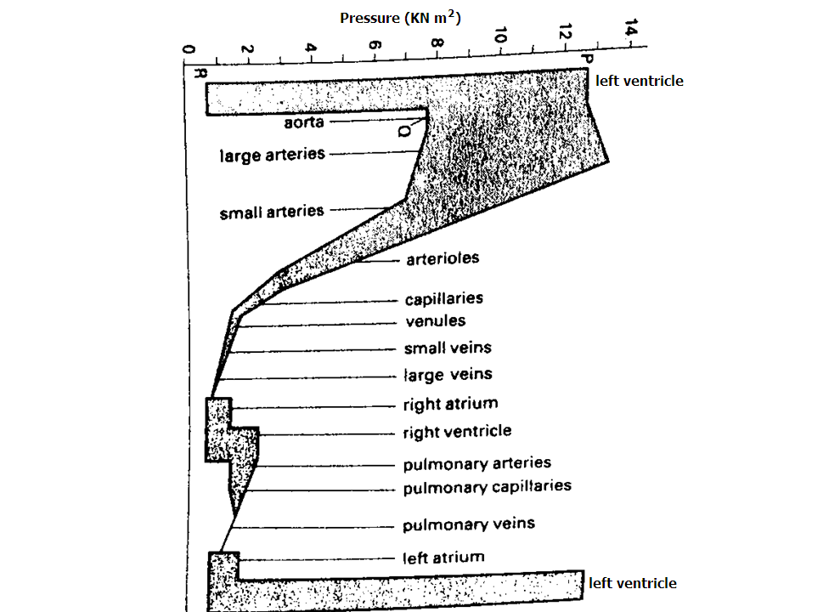

1. With reason state which part of the circulation shows the greatest fluctuations in pressure? (4 marks)
2. Which parts show no fluctuations? Explain. (4 marks)
3. With reason state which part of the circulation always maintains a pressure above 7.5kNm-2 (4 mark)
4. Describe the factors which exert the pressures evident at i) P (4 marks)

ii) Q (4marks)

iii) R (4 marks)

1. Suggest the sector of the circulation which offers the greatest resistance to the flow of blood. How is this indicated by the diagram? (3 marks)
2. Blood flow in the main veins is under relatively low pressure. Describe how the return of blood to the heart is maintained (3 marks)
3. Account for the different ranges of pressure in the pulmonary and systemic circulations. What are the advantages to the mammal in having a double circulatory system? (5 marks)
4. Describe the structural and physiological features of cardiac muscle which distinguish it from skeletal muscle (4marks)
5. Explain what would be observed in the pressure of the left ventricle if the person went for a 100m race. (5 marks)

**SECTION B**

2. a) What is meant by mutual inhibition? (3 marks)

b) Explain the importance of mutual inhibition in vision (4 marks)

c) Using a named example, explain what is meant by summation. (6 marks)

d) Explain the importance of retinal convergence in vision (6 marks)

3. a) By means of an annoted diagram, describe how gaseous exchange occurs in a protist such as amoeba (6 marks)

b) Describe the nervous control of breathing in a mammal (14 marks)

4. a) Explain what is meant by geographical distribution. (2 marks)

b) Explain why **North America** and **Eurasia** have similar fauna yet Africa, South America and Australia have markedly different mammalian genera and species despite being with similar climatic conditions and on the same latitude. (14 marks)

c) How does the fossil theory of the ancient Reptile **Mesosaurus** give evidence to continental drift? (4 marks)

5. (a) Describe the process of alternation of generations in a named bryophyte. (16 marks)

(b) Explain the significance of the gametophyte generation in the bryophyte named in (a) above. (04 marks)

6. a) The Hatch slack path way is an efficient carbon dioxide fixation mechanism. Explain why not all plants use it to fix carbon dioxide? (6 marks)

b) Explain why the photosynthetic efficiency of C4 plants is higher than that of C3 plants (8 marks)

c) Account for the mechanism of carbon dioxide fixation in CAM plants. (6 marks)

**END**